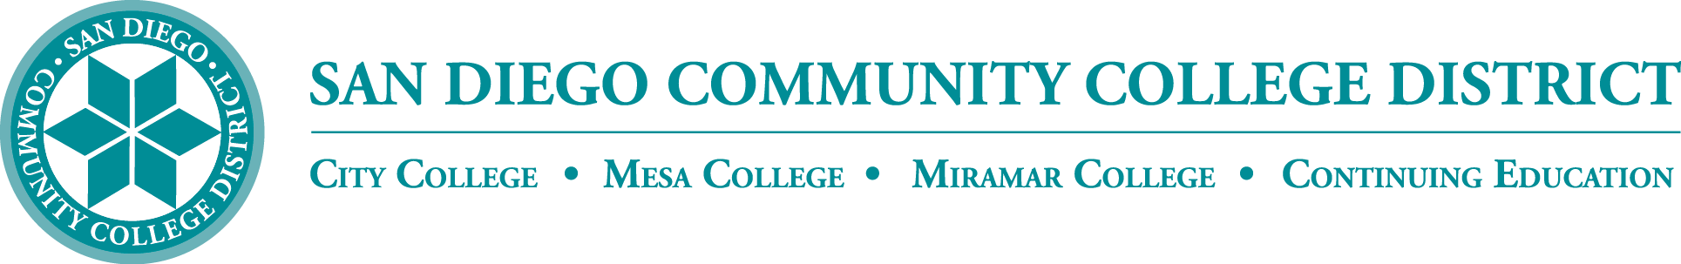

District’s Educational Services Software Workgroup
February 15, 2024
11:00 a.m. – 12:30 p.m.
Meeting Notes

Members:
Aaron Detty, Aaron Iffland, Amertah Perman, Anne Gloag, Brian Weston (Chair,) Cara Smulevitz, Charlie Lieu, Cheryl Reed, Claudia Tornsaufer, Darius Spearman, Denise Munoz, Elizabeth Barrington, Ingrid Greenberg, Isabel O'Connor, Jay Pope, Jill ODea, John Bromma, Katie Palacios, Kelly Rosas, Laura Murphy, Ljubisa Kostic, Manuel Velez, Matilda Chavez, Matthew Rivaldi, Maureen Curry, Michelle Fischthal, Monica Romero, Nancy Wichmann, Paul H. Alexander, Peter Haro, Peter Maharaj, Poppy Fitch, Rechelle Mojica, Robbi Ewell, Russ English, Star Rivera-Lacey, Stephanie Lewis, and Stephanie Major. Academic Senate Presidents: Andrew Hoffman, Paul Alexander, Paul (Pablo) Martin, and Richard Weinroth

ESSW Workgroup

SDCCD strives to leverage the buying power of our colleges and other community colleges across the state. We have enabled transparency by sharing our website that shows what software is available for faculty and for students across the district here https://www.sdccd.edu/about/departments-and-offices/instructional-services-division/online-learning-pathways-1/faculty/software_sdccd.aspx

OIER Districtwide Survey

Michelle Fischthal, Vice Chancellor of the San Diego Community College District Office of Institutional Innovation and Effectiveness presented results from the Fall 2023 Employee Survey on Innovative Practices and Emerging Technologies. Notes from the presentation are reflected below.

The purpose of providing the survey is to understand the current landscape of innovation practices and emerging technologies within our institution. The presentation aimed to highlight the key findings, provide insights into the adoption, challenges, and future direction of these technologies among the staff and faculty.

There were 389 survey respondents, representing the four colleges and District Office. Mesa (96) and SDCCE (97) had the highest volume of survey respondents. Respondents included district staff from Executive Management, NANCE, Contract and Adjunct Faculty, Classified, Confidential, SPAA, and Management.
Innovative Practices/Emerging Technologies currently used in work or classroom survey results:
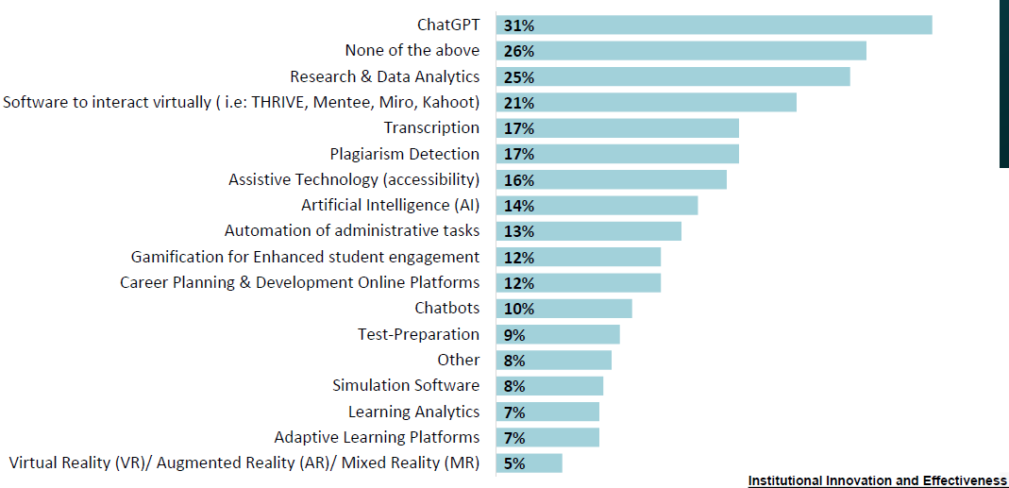
The survey found 41% or 128 respondents are interested in exploring emerging practices; top areas of interest: Artificial Intelligence, ChatGPT, Canva, Augmented Reality, and Virtual Reality.
ChatGPT Usage:

•ChatGPT (31%) is the top technology used
•Research & Analytics is the second (25%)

Challenges:

•Haven’t had time (47%)
•Lack of knowledge (42%)
•Lack of resources (35%)

Technology Application:
The main three ways these technologies are used:
•Creating efficiencies in work tasks (34%)
•Communication (33%)
•Conduct administrative/project tasks (33%)

Support Needed:
•Access to updated hardware/software (57%)
•Dedicated tech support (51%)
•Training (50%)

Michelle shared survey comments with the group and reviewed the proposed next steps:

Professional Development and Training
Implement AI training sessions and pop-up campus visits with hands-on opportunities for AI and AR/VR technologies.

Resource Planning and Allocation
Develop detailed planning documents for AI and AR/VR, identifying resource needs and exploring funding opportunities.

Student Engagement
Initiate AI student workshops and industry-specific AR/VR opportunities to enhance learning experiences.

AI Certificate Program
Establish an AI Certificate Program for SDCCD employees, focusing on the practical application of AI in educational settings.

Identified Resources:

Financial Investments
Budget for AI and AR/VR software/hardware, training programs, IT support, and infrastructure upgrades.
Human Resources
Recruiting AI and AR/VR specialists, analysts, IT staff, and training faculty and staff in both technologies.

Technological Tools/Facilities
Acquisition of AI platforms, AR/VR equipment, and modern computing hardware.
Partnerships
Form strategic partnerships and engage in collaborative efforts with industry leaders in AI and AR/VR to gain valuable insights and foster the integration of real-world applications within educational settings

Policy Development
Formulating policies and governance structures for the ethical use of AI and AR/VR within SDCCD.

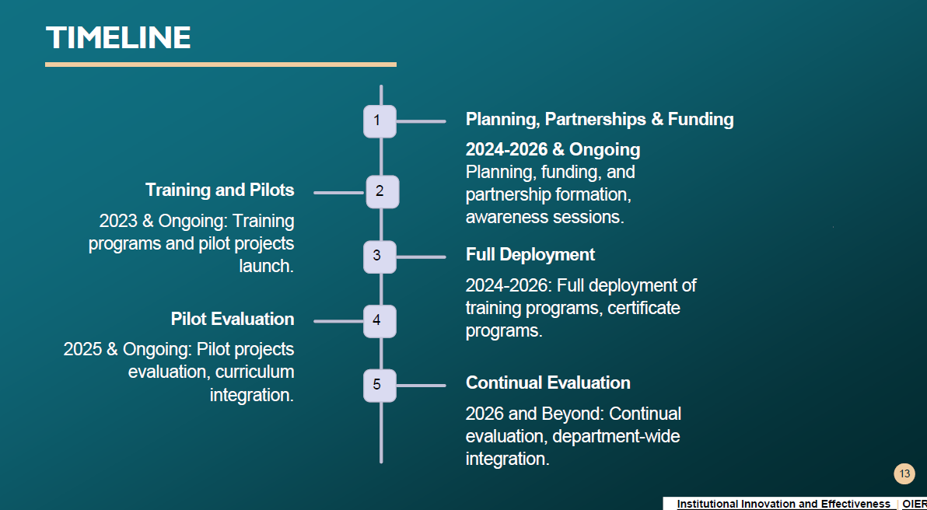

OIER DRAFT TRAINING SCHEDULE –DIGITAL LITERACY IN AI

Feb 23 - AI Demystified: Introduction to Generative AI
Follow-Up Hands- on Workshop: Crafting AI Syllabi Policy

March 1 - Mastering AI Literacy, Including Prompting
Follow-Up Hands- on Workshop: Elevating Educational Content with AI

March 8 - Art from Words: Crafting Art with AI
Follow-Up Hands- on Workshop: Exploring AI’s Creative Frontiers

April 5 - Emerging AI Leaders: Engaging with the Student Perspective
Follow-Up Hands- on Workshop: Empowering Learning with AI

April 19 - Navigating the AI Landscape: innovation & Entrepreneurship
Follow-Up Hands- on Workshop: Showcasing AI Breakthroughs

May 23 - AI and Web3: Synergy in the next Frontier
Follow-Up Hands- on Workshop: Building Tomorrows AI Innovation

Survey results can be found here: chrome-extension://efaidnbmnnnibpcajpcglclefindmkaj/https://www.sdccd.edu/docs/iie/Research/SDCCDInnovationPracticesandEmergingTechSurveyResultsGraphs.pdf

AI Tools
There have been many discussions about AI districtwide. Many of those conversations are about how AI relates to education. Brian thanked Vice Chancellor Fischthal for her presentations, along with Professor Gomez and Grossmont’s Professor Roe. The district has developed an AI Tools and Resources website and SDCCD DE Toolkit with faculty resources.
Faculty have asked for help creating syllabi language and we are working on that now. We are also working on increasing the support for different variations of assignments and how different tools and digital literacy can be expanded in our classrooms for both instructors and our students. We are learning that students are going into jobs that are already incorporating these AI tools, whether it be a large language model for writing, for image generation, or other things.
Last semester we talked about TurnItIn. TurnItIn enabled a beta detector in our instance of Canvas without approval. They turned it on for all TurnItIn customers across the state. The beta trial ended in December 2023. During that time we have received different reports from various institutions and different publications on the validity of these detectors. Questions arose about the use of these detectors and some of the equity concerns that have been flagged. OpenAI decided to stop offering their detector because of inaccuracies and not being able to maintain the updates to detect different models. We learned recently that Copilot is available in our instance at SDCCD. The Copilot data that you use will be contained within SDCCD, which is another important conversation. We have access to GPT 4 and to DALL-E through a version of Copilot, you can either download the app or access the web version. The cost for TurnItIn AI detector is $20,000, but it has questionable accuracy rate for students.
Aileen shared there is a demand for AI detectors particularly for the larger courses. For example teaching 5 sections of a humanities class with 50 people in each section. Aaron agreed that it is helpful to have that third-party report to be able to start the conversation with the student “Here's why I'm approaching you.” Kelly’s concern is that there are faculty who are not going to use it as thoughtfully, and may fail a student or give them a zero when receiving a false positive. Kelly also thinks it is an equity issue because there are students who can use AI and get away with it and can get past the detectors by putting work through a paraphraser. Charlie would like to see some type of training for our student support programs; so students are not only hearing from the instructional side of the house, but they are also hearing it from student services about how to properly use AI. Miramar was not available for comment. Jessica shared that she appreciates being cautious about the false positives on the reports because it's especially troubling from an ESL background. Many of our ESL learners are being flagged for their speech and language patterns. The topic will be brought to a future ESSW meeting for further discussion.
Canvas and Campus Solutions SSO
Single sign-on will be launched after the census in fall 2024. We will be logging into the system using email as the single sign-on and no longer using the 10-digit sign-on.
College Buys & STAC-STARTE

The STAC-STARTE program centralizes the ordering of online teaching, learning, and student support tools. The System wide Technology Access Collaborative (STAC) is a system wide collaboration between the California Community Colleges Chancellor’s Office, the Foundation for California Community Colleges’ CollegeBuys program, and the California Virtual Campus initiative. Here are the participating vendors for 2024-2025.

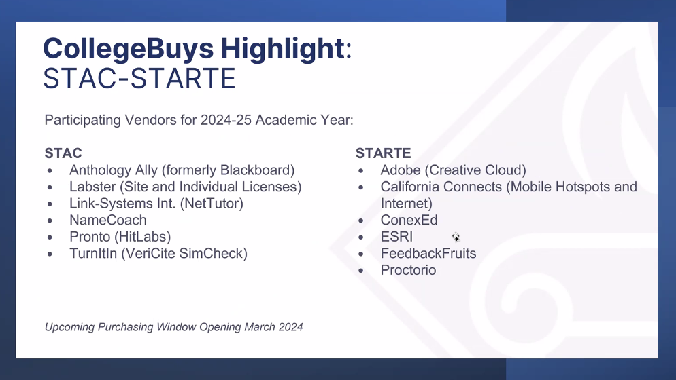
The state is looking at how they can collectively leverage cost savings. A good example is how we all moved to Canvas as a state system. Generally, if six districts are using a product, we can take it to the State and ask for some negotiated purchasing power.

Next Meeting: April 18, 2024

Respectfully submitted by: Mary Kingsley, Educational Services

