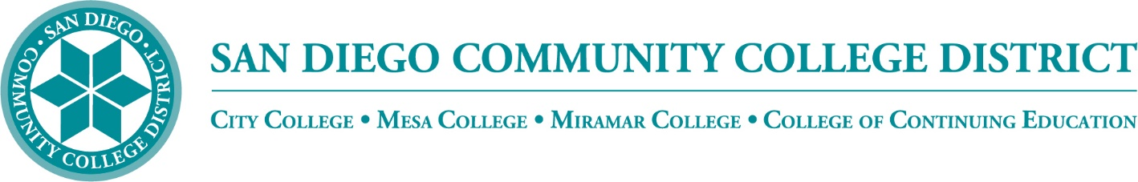

District’s Educational Services Software Workgroup
March 17, 2022
11:00 a.m. – 12:30 p.m.
Meeting Notes

Members:

Aaron Detty, Aaron Iffland, Andrew MacNeill, Anne Gloag, Brian Weston (Chair,) Cara Smulevitz, Charlie Lieu, Cheryl Reed, Claudia Tornsaufer, Darius Spearman, Denise Munoz, Elizabeth Barrington, Ingrid Greenberg, Isabel O'Connor, Jay Pope, Jill ODea, John Bromma, Katie Palacios, Kelly Rosas, Laura Murphy, Ljubisa Kostic, Manuel Velez, Matilda Chavez, Matthew Rivaldi, Maureen Curry, Michelle Fischthal, Monica Romero, Nancy Wichmann, Paul H. Alexander, Peter Haro, Peter Maharaj, Poppy Fitch, Rechelle Mojica , Robbi Ewell, Russ English, Star Rivera-Lacey Stephanie Lewis, and Stephanie Major.

STAC Timeline

The Systemwide Technology Access Collaborative (STAC) is a systemwide collaborative between the California Community Colleges Chancellor's Office, the Foundation for California Community Colleges' CollegeBuys program, and the California Virtual Campus initiative to centralize the ordering of online teaching, learning and student support tools. 103 CCCs participated in the most recent STAC purchasing window. STAC will reopen in mid-March 2022 for 22-23 Academic Year services

Canvas Studio

Canvas Studio will not be paid for by the State. They had previously paid for two years during the pandemic to help facilitate online learning. SDCCD has decided to keep the contract and the license will be paid with contributions from each of the colleges.

Proctorio

Proctorio is no longer offered as a service. None of our colleges are using Proctorio through the STAC agreement.

STAC Purchases

What can we purchase through STAC? They have Easy-Soft, Labster, Name Coach, NetTutor, Ouriginal, Pronto, TurnItIn. SDCCD had a trial with Blackboard Ally, the software had great features but the license was cost prohibitive. The State is offering some support with NetTutor at 250 hours per college ($23/hr additional hours). SDCCD does have a Pronto license in use through Canvas, we are on our third year; instructors reported good use. The District was using Unicheck plagiarism tool, we have decided to purchase TurnItIn Similarity license as a District. The District is using Zoom which is still being paid for through CCC TechConnect.

Brian shared a PowerPoint listing resources available through STAC

He also shared which software licenses are currently active in the District:

Canvas Studio is being paid by all the VPIs and we will be continuing that service throughout the 2022-2023 academic year.

Canvas Phone Support is being funded from the colleges, this compliments Canvas Chat Support. Brian shared that Canvas support can masquerade as a student, but does not provide live screen sharing. Currently we have 24/7/365 helpdesk support services for all SDCCD Canvas Users powered by Instructure, Inc. The State continues to provide funding for Canvas Chat Support.

The District has access to Microsoft 365. Office 365 includes Word, Excel, PowerPoint, OneNote, and now Microsoft Teams, plus additional classroom tools.

SDCCD has selected TurnItIn Similarity for anti-plagiarism detection software in the new year. All three colleges provided funding. There will be a transition from Unicheck to Turnitin and there will be training offered.

Zoom Sub Accounts

We have Zoom sub-accounts starting slated for July 1. We will be reviewing and possibly paralleling recommendations of zoom options from the State. We will be reviewing features and setting up default parameters. Brian thanked IT for their work on this. There might be features that we want enabled or disabled by default or possibly restricting certain features for continuity.

Next Meeting: Thursday, April 21, 2022

Respectfully submitted by: Mary Kingsley, SDCCD ONLINE

