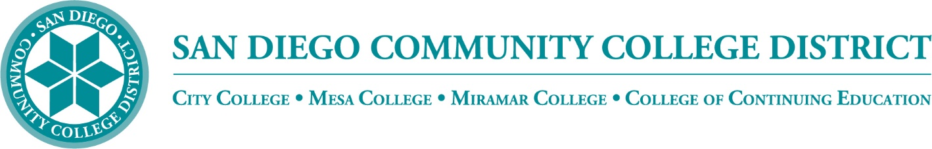

Districtwide - Student Textbook Affordability Committee (STAC)
December 1, 2022
2:00 p.m. – 3:00 p.m.
Meeting Notes

Members:

Allen Kuo, Angela Boyd, Anne Gloag, Brian Palmiter, Brian Weston, Desiree Payne, Diana Vera-Alba, Edward Borek, Lily Cava, Lisa Burgert, Nancy Wichmann, Pegah Motaleb, Rob Meyers, Sol Madrid, and Victor DeVore

Low Textbook Cost – ZTC Class Search

Victor has been working on the LTC-ZTC icon for the online class schedule. Brian thanked the group for their work and input selecting the icon. Victor is currently working on programming and timelines. He plans to report to the committee with updates at future meetings.

Brian reported that CCE is hoping to offer a similar LTC-ZTC search for their class schedule. Although CCE is not bound by SB 1359, having a search added to their online class schedule would help students find courses that are low to no-cost and would be of benefit. Brian has reached out to the Dean of Student Services who is interested in the programming work required and will work on solutions on how we can standardized the reporting of CCE data to make it similar to how the credit colleges report their data. Diana reported that the VP was concerned with infrastructure changes necessary to implement the project. Brian would like to have a separate meeting to find out how CCE information is being reported at present and what if any changes are necessary. He plans to meet with Victor, Diana, Desiree, and Nancy to work out the programming needs and find out what data is required. Brian will send out an email to get planning started and hopes to have more conversations next semester.

Affordability Board Report

The Affordability Board Report requests that the district reports our projected cost savings on LTC/ZTC. Brian reminded the group that he will be asking all campuses to report on their efforts and initiatives and progress made at each college. We will gather the data into a report to let everyone know how much we have accomplished. The report is usually published in spring so this is a heads up that information will be requested.

OE Week

OE Week is March 6-10, 2023. Brian will be asking this group for presenters and ideas for workshops showcasing what we can do with open resources. Also, If you have suggestions for instructors that have exemplary work we would like to showcase that work.

Community Project Grant

The Community Project Grant work is in progress, we have developed an OER job description to support the conversion of courses into ZTC. We hope to have that person on board by the start of the next semester.

We had sixteen applications for CFG funding that met the first deadline. After intensive review, we have determined that fifteen of the applicants will proceed. We are finalizing the funding amounts today. We will be staging the projects so we will be able to provide the necessary support.

Districtwide Department Leads

Lisa would like this group to consider Districtwide Department Leads that would receive a stipend from the $20k allocated for each college. This would follow Mesa's Online Student Success teams model where they have faculty across each discipline that support other faculty.

Brian likes the idea of discipline experts helping instructors across the district with OER implementation. The $60k has been discussed in the past and will be used to help fund a united effort to identify ZTC districtwide pathways. Brian will be meeting with Institutional Research (IR) to find out how to develop a dashboard that would track the ZTC pathways. After we identify pathways, there is more funding available from the state. If we have a pathway already identified, we can submit for up to $200k in funding. This added funding could be used for discipline experts to help with efforts across any of the colleges to develop OER. Brian surveyed each campus and will meet with IR to discuss the possibilities.

Next Meeting: Thursday, February 2, 2023, 2:00-3:00pm

Respectfully submitted by: Mary Kingsley, SDOLP

