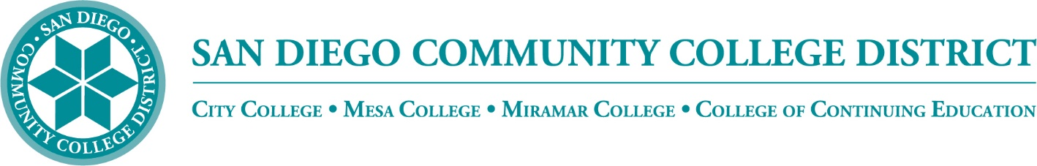

Districtwide - Student Textbook Affordability Committee (STAC)
March 2, 2023
2:00 p.m. – 3:00 p.m.
Meeting Notes

Members:

Allen Kuo, Angela Boyd, Anne Gloag, Brian Palmiter, Brian Weston, Desiree Payne, Diana Vera-Alba, Edward Borek, Lily Cava, Lisa Burgert, Nancy Wichmann, Pegah Motaleb, Rob Meyers, Sol Madrid, and Victor DeVore

Meeting Notes

The meeting notes from February 2, 2023, meeting were reviewed. Melanie moved to approve, and Angela seconded.

Book Vouchers

The group briefly discussed the restrictions on book vouchers issued to students by financial aid. It was decided to wait for more information and clarification from our bookstore representatives at a future meeting.

Class Search - Access Codes

California AB 2624 requires colleges to ‘prominently display’ the estimated costs for each course in the online class schedule. Access codes are used to purchase additional study materials linked to a specific textbook or online course. Currently, students are notified that an access code is required when they select the course section’s ‘instructional materials’ field. Brian received a request to identify course sections that require the purchase of an access code via an ‘icon’ in the online class schedule. Brian discussed access codes and asked the group if there should be a new class search icon added to these sections for more easy identification by students. The group considered cost-transparency and the importance of students receiving all cost information upfront when making their course section choices. The majority agreed that it would be beneficial to students to disclose the access code requirement using an icon and disclose the requirement again under the instructional materials field. We will work with the bookstore and student services to address feasibility.

Zero-Textbook-Cost Degree Grant (ZTC) Program

CCC’s Vice Chancellor of Educational Services and Support sent out a memo 2/23/23 with updates on the Zero Textbook Cost Program.

Phase 1 - ‘ZTC Planning Grants’ consist of $20k grants to 115 colleges to begin planning the development of a ZTC program. To be eligible to receive subsequent phases of the ZTC grant, colleges will need to review the ZTC program assurances and complete their certification online by March 31, 2023. Working with student services, we have been using this funding to identify ZTC degree pathways.

Phase 2 - ‘ZTC Acceleration Grants’ competitive grants used for the development and implementation of ZTC degree programs. Interested colleges will apply by responding to the Chancellor’s office Request for Applications (RFA). The RFA and proposed timelines will be released in Fall 2023. Awardees may receive up to $200,000 for each degree developed and implemented.

Phase 3 - ‘ZTC Implementation Grants’ consist of $180k grants and are the follow-up to the Phase I ZTC Planning Grants. Colleges will design, develop and pilot a ZTC degree. Colleges will need to submit a work plan by October 2023 and complete implementation and reporting by December 2024.

Board Report

The Board of Trustees is not asking for an OER presentation to the public this year. Working with the bookstores, we will still be gathering data and working on an OER Affordable Textbook Cost Impact Report. Brian would like to work with Committee members to highlight their college’s progress across the year. Once generated, the report will be distributed to our stakeholders and will describe our current efforts and highlight all the work that we have done over this past year.

OE Week

SDCCD OE Week is March 6-10, 2023. A full schedule has been planned and provided to the colleges for distribution. The event is published in the District’s newsletter sent out on March 1, 2023. In addition, each college is advertising the event through the OER liaisons. Brian provided the link to the event activities schedule at https://www.sdccd.edu/about/departments-and-offices/instructional-services-division/online-learning-pathways-1/faculty/oer_week-2023.aspx

Next Meeting: Thursday, April 6, 2023, 2:00-3:00pm

Respectfully submitted by: Mary Kingsley, SDOLP

