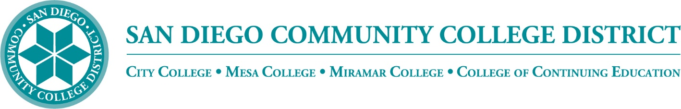

**Districtwide - Student Textbook Affordability Committee (STAC)**

**April 3, 2024 2:00 – 3:00 p.m.**

**Meeting Notes**

**Members:**

Allen Kuo, Angela Boyd, Anne Gloag, Brian Palmiter, Brian Weston, Desiree Payne, Devika Chhabra, Diana Vera-Alba, Edward Borek, Kelly Spoon, Lily Cava, Lisa Burgert, Maddie Button, Melanie Nakaji, Nancy Wichmann, Pegah Motaleb, Rob Meyers, Sandra Pesce, Scott Kraus, Sol Madrid, and Victor DeVore

**Book Store Orders**

Brian encouraged the members to promote faculty text orders which will help our students plan their schedules and to ready for the new semester. We have made some improvements on textbook orders, but there is still work to be done and we would like to see 100% participation. Nancy asked what date has been set for Fall semester book orders. She added that they just sent out summer textbook request information and did not want any confusion. She reported that the campuses have been making great progress in semester preparedness. The email sent to instructors states the textbook order is due when the assignment is received. Brian added that students should have the information when registering for the course. Victor reported that 40% of courses will display costs by January 2025 and improve to 55% of courses by 2026. He hopes to increase that by 10% every year.

**Class Schedule Icons**

Textbook reporting is important so students can make an informed choice when registering for courses. The textbook icon status needs to have materials-cost information in the system so that the course be tagged and marked appropriately. When the class schedule gets released, it needs to have the right information associated with the courses. We are working with both the *ZTC icon* and the *low textbook cost* icon. The ASCCC has reduced the set number for *low cost* to under $30. We had previously set *low cost* for anything under $40.When possible, *zero textbook cost is preffered*, but it is nice to recognize the faculty out there that have done wonderful work and reduced their textbook cost while still maintaining the high-quality materials. The icon change has been in the queue with XB 12 data reporting. The hope is for it to launch this Fall. There's a lot of back-end work involved. Brian thanked the staff in Student Services and IT that have been working on this project.

**ZTC Tracker**

The colleges originally received grant from the CCC Chancellor’s Office to track *low textbook cost* courses. SDCCD implemented a ZTC Mapper which is populated with information reported and pulled from the bookstore. You can view the tracker here <http://www.ztctracker.com/>. Information is provided by college, department, and program as shown below:

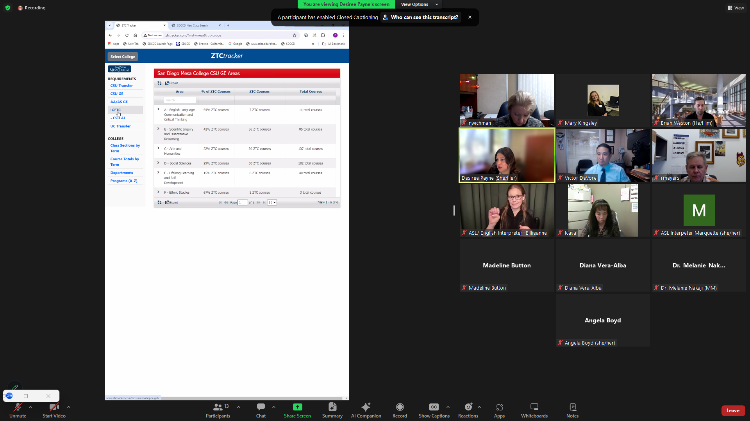

Brian shared that this program provides an overview that saves semester information by terms. Diana asked if VPIs and Presidents have been included in XB12 concerns and how non-credit courses are tracked. Victor shared we do MIS reporting at the end of the semester. We will not report this spring until July. We are still working on courses like ESL who loan course materials for Continuing Education courses at *no-cost* or more approriately *no-cost-for-students*. Where there is a cost associated with the course, but the cost is not passed to the student. Brian shared that we have updated the Textbook form sent from the Bookstore to include different scenarios such as textbooks provided by the college. Brian thanked the group, especially Nancy and Bookstore crew for her help in the report to the Trustees.

**Grant Opportunities**

Brian will be hosting a workshop on April 15. The state is offering many grant opportunities. The state is offereing an OER expansion grant offering a $20k/per course along with additional $200k grants for pathways. Brian welcomed the group to join the workshop. He added that we still have funds from the Community Funding Grant and are working on different ways to provide support.

**Announcements**

The 2024 Open Education Conference (OpenEd24) will be held on October 8-10, 2024 as a hybrid event, with in-person attendance hosted in Rhode Island and virtual attendance available. More information can be found here <https://openeducationconference.org/2024>

Cal OER 2024 will be held August 7-8, 2024. This is a virtual conference and more information can be found here <https://www.caloer.org/>.

Celebrating ZTC in the CCC will be held May 3, 2024 on the Valencia Campus of College of the Canyons in Santa Clarita, California. Free registration. More information can be found here <https://sites.google.com/view/ztctap/home/conferences>

**Next Meeting:** Thursday, May 1, 2:00-3:00 pm

*Respectfully submitted: Mary Kingsley, SDOLP, District Educational Services*